**Stats in ML**

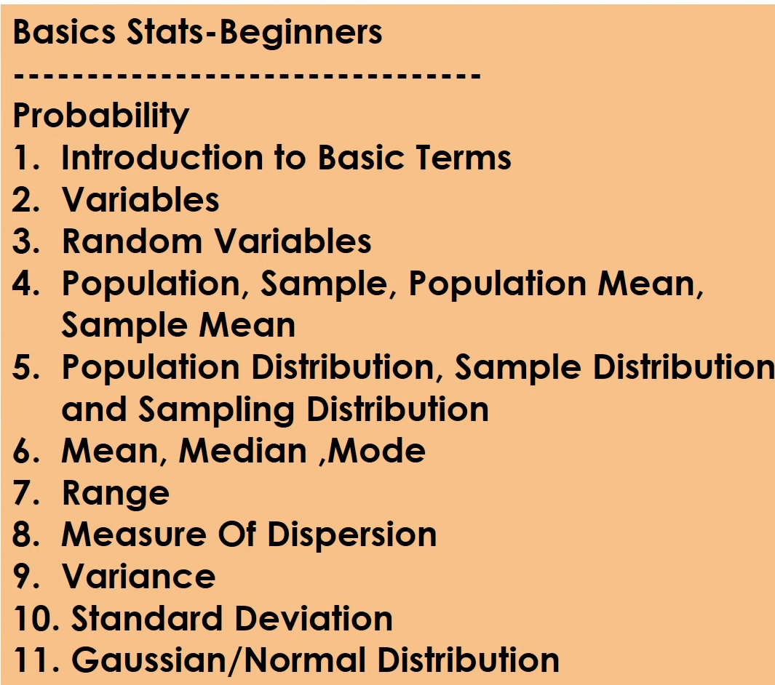

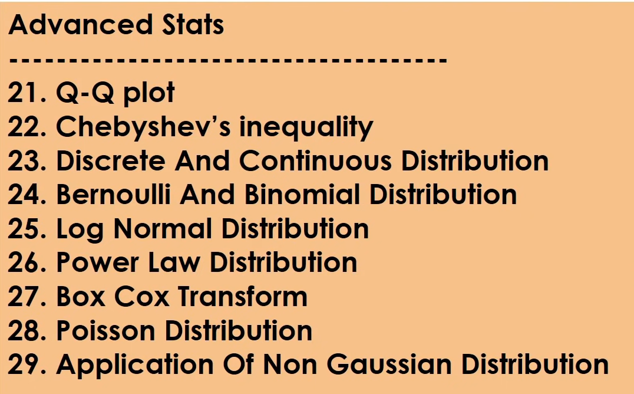

Video -2

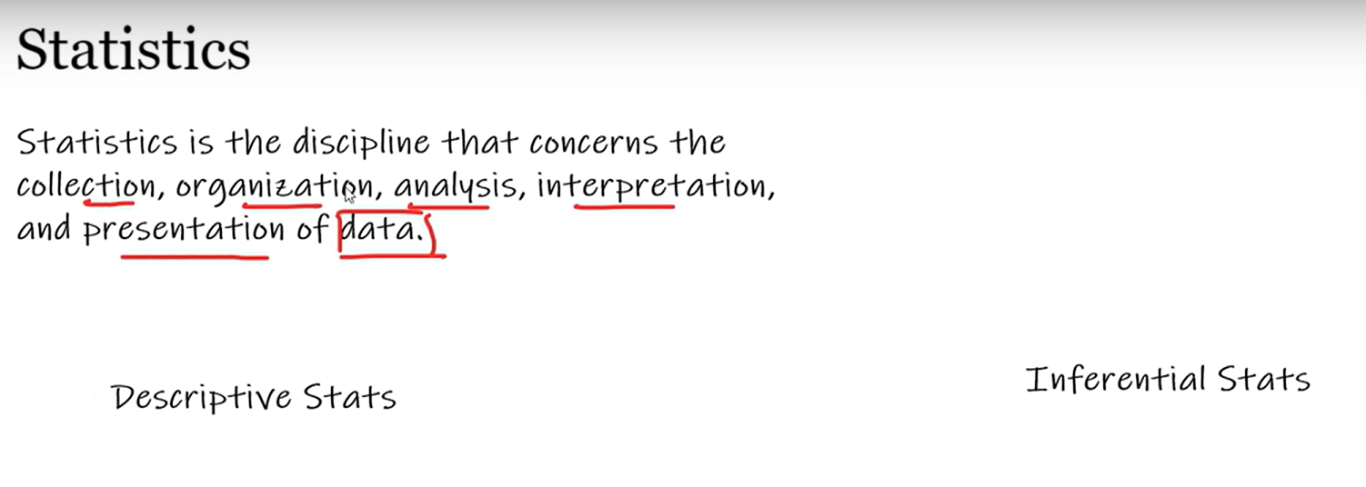

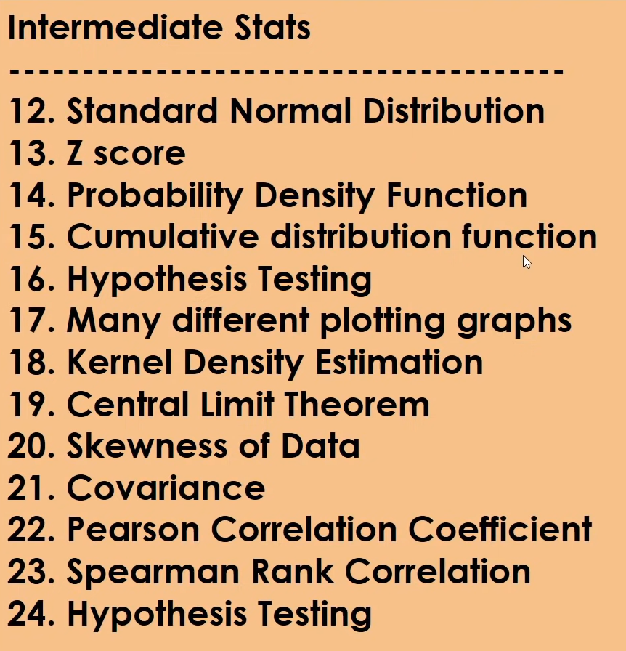

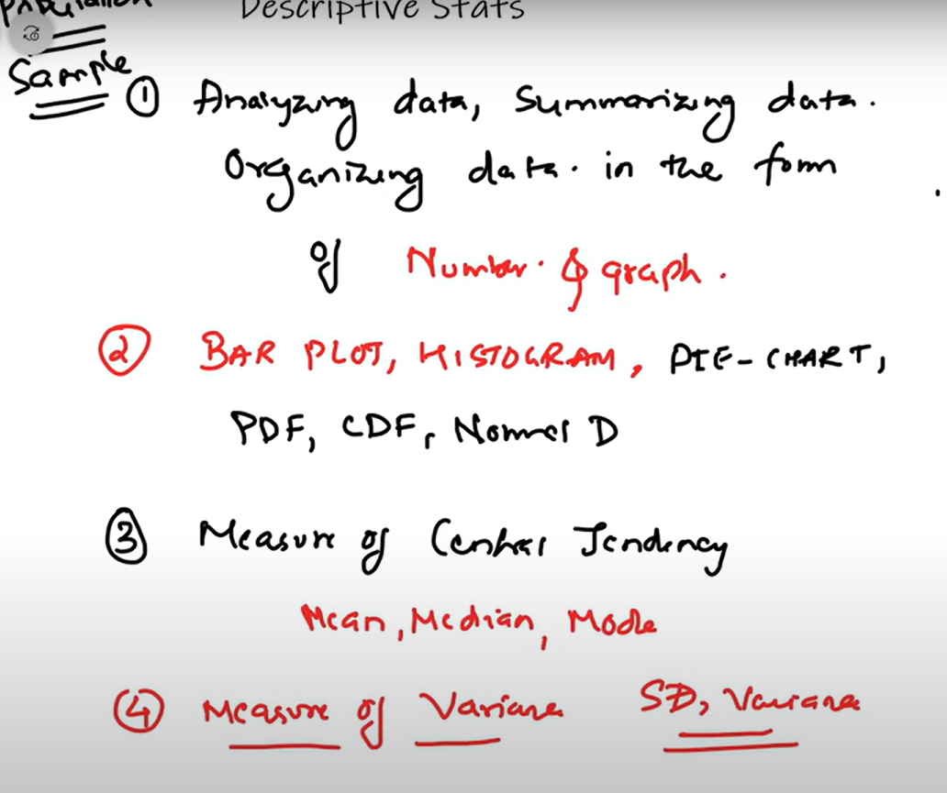

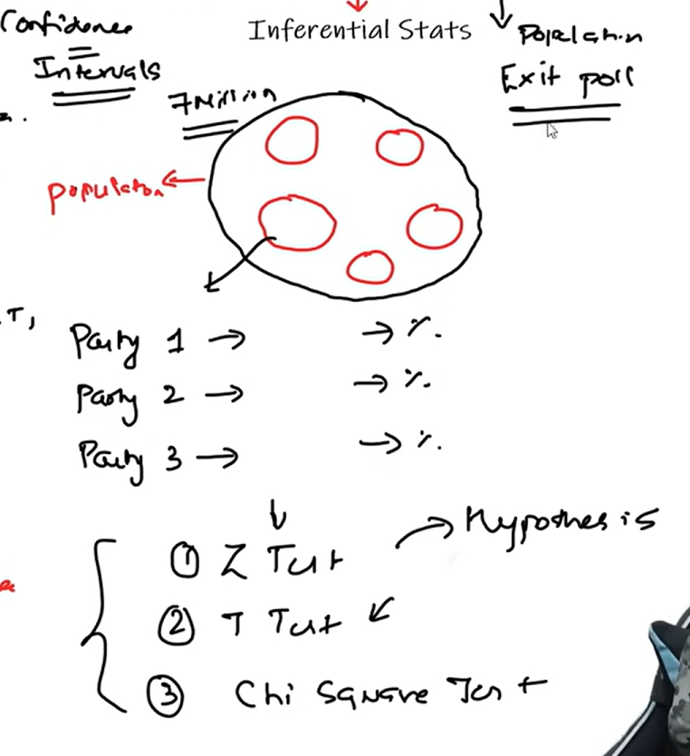

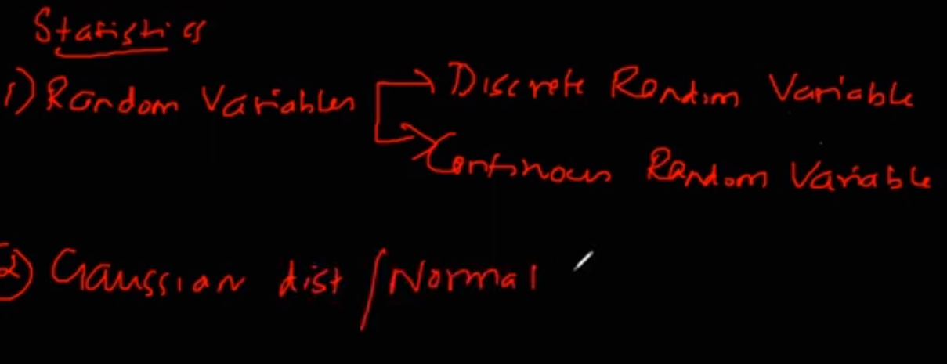

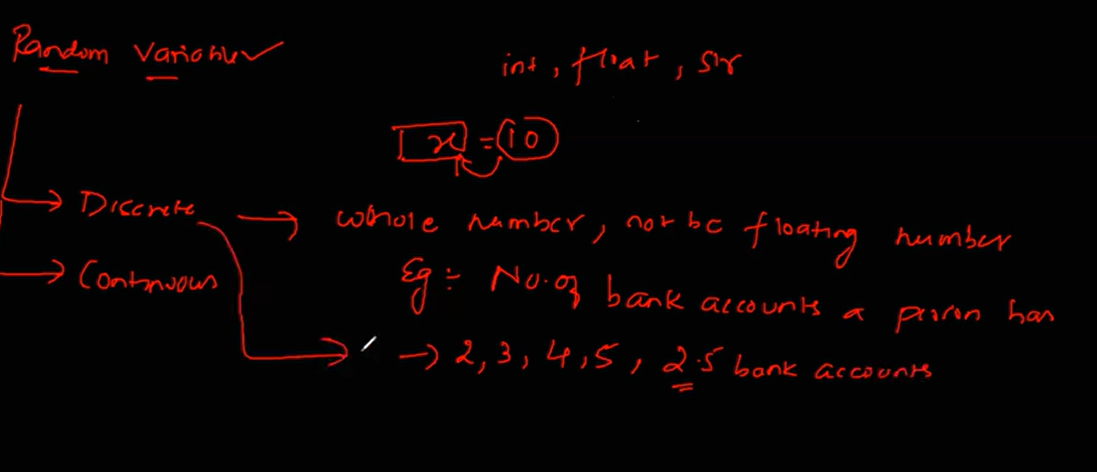

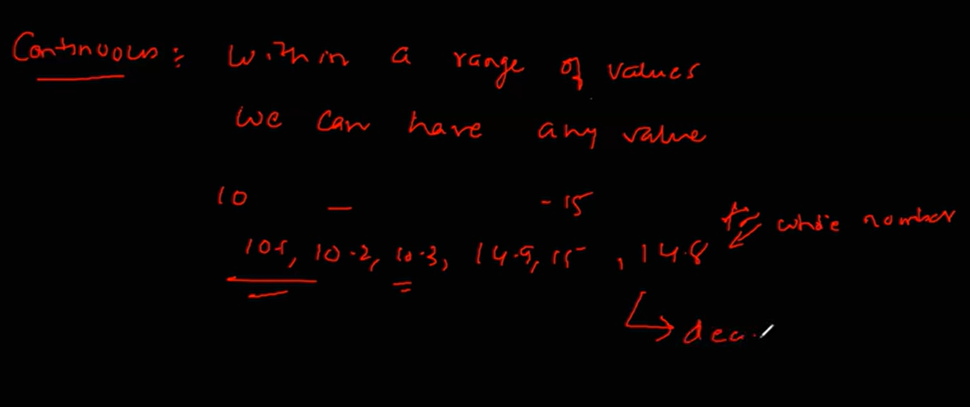

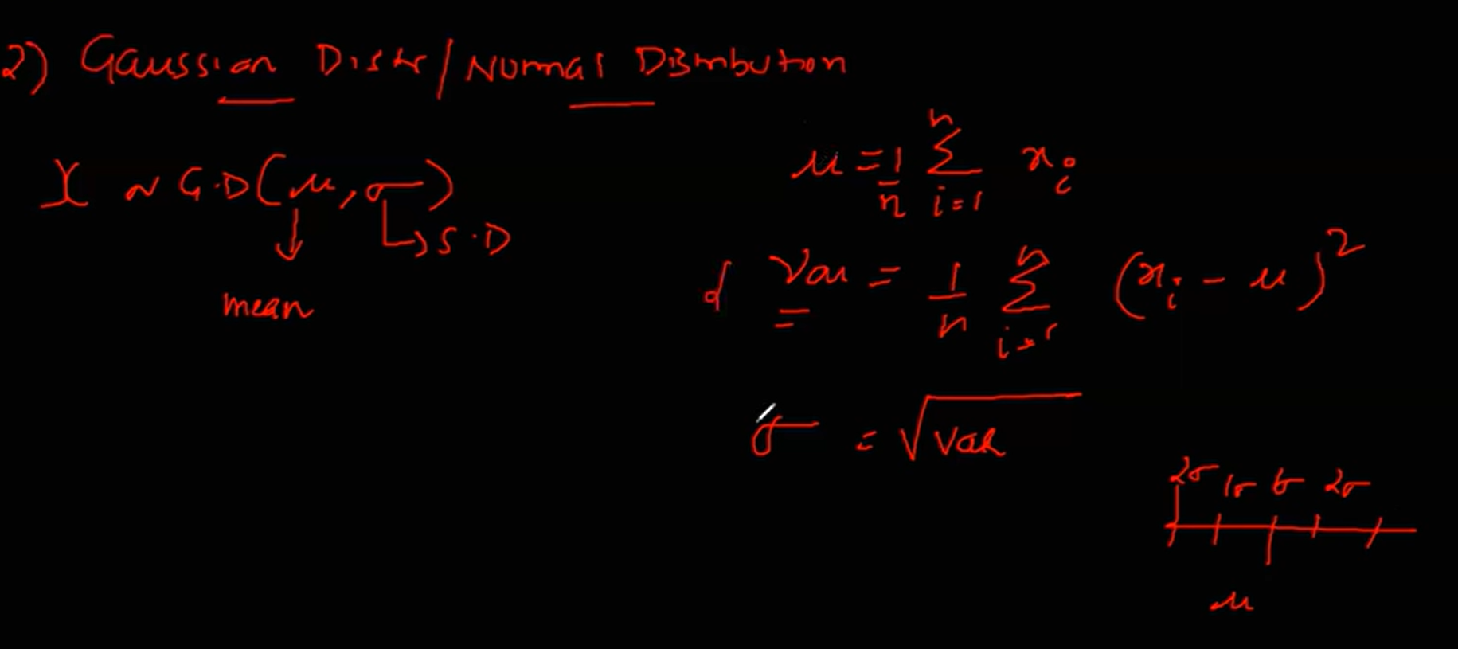

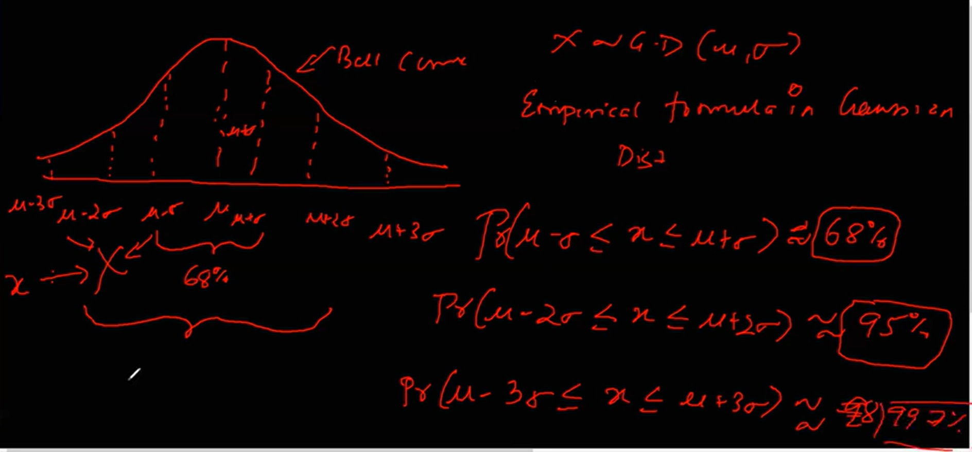

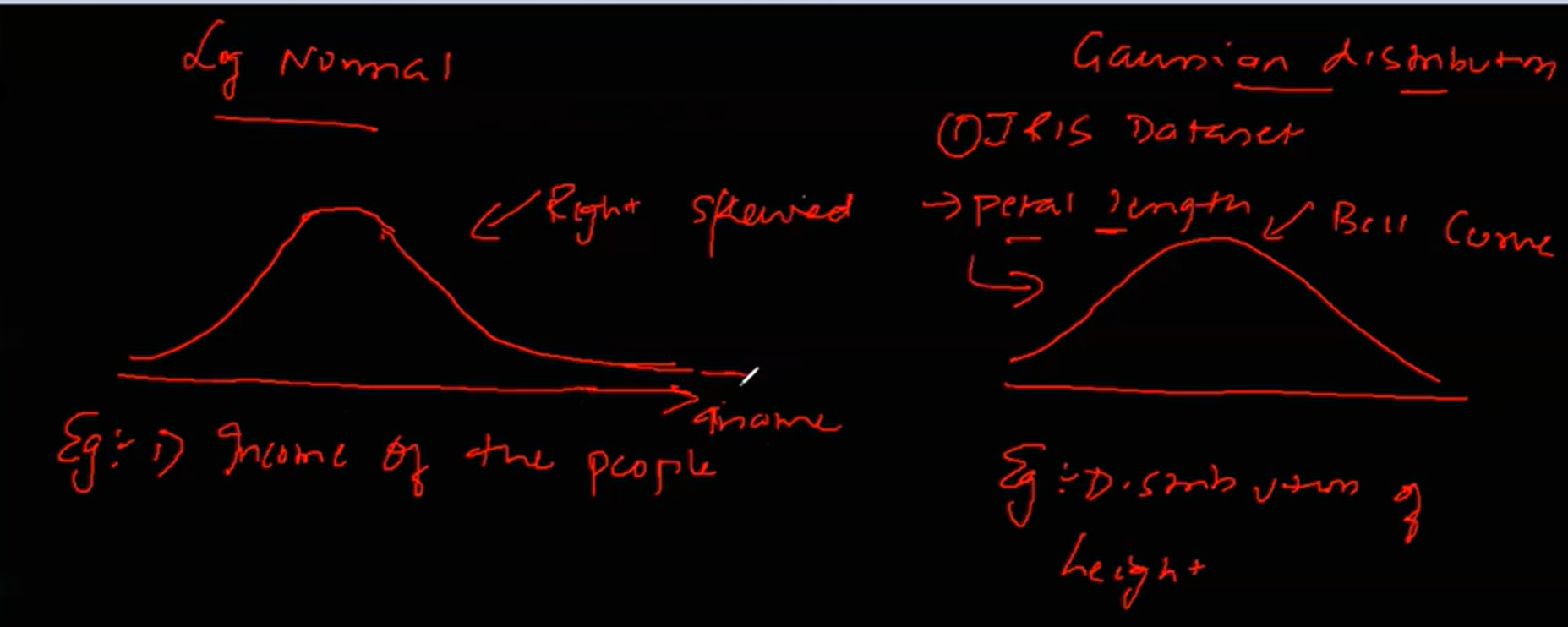

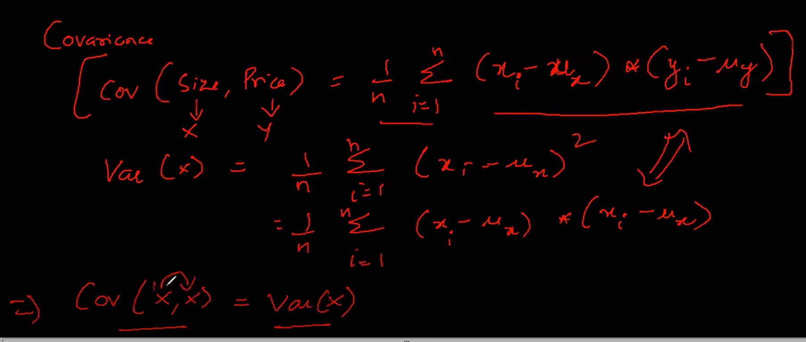

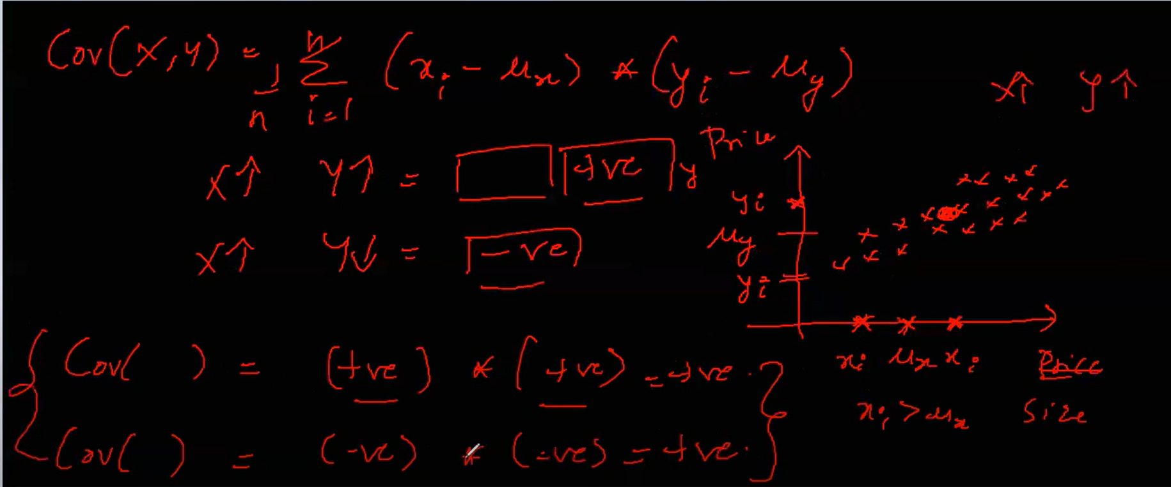

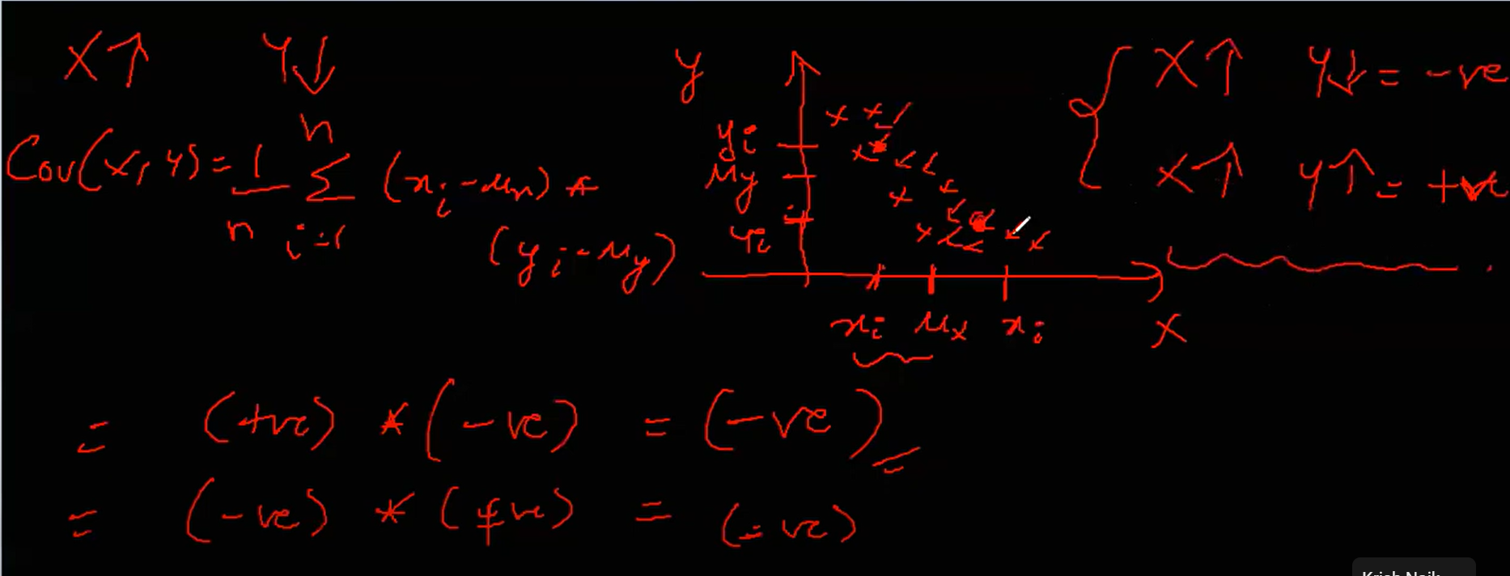

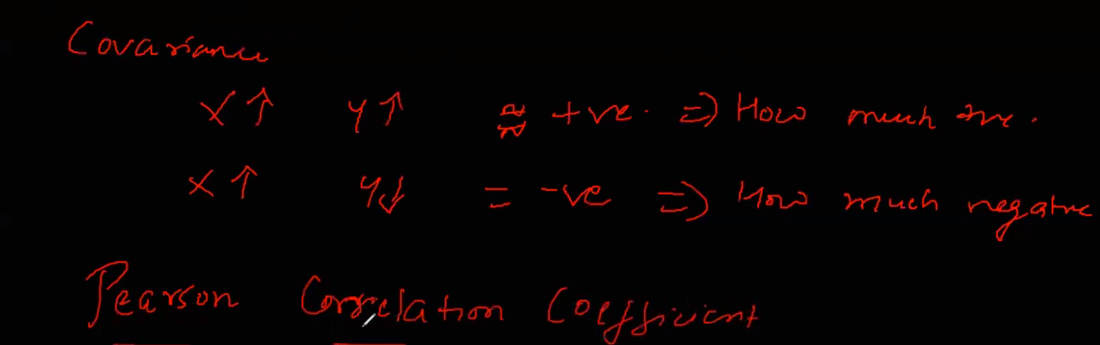

Covariance doesn’t tell how much it is positive or negative. So we use Pearson Correlation Coefficient to find it out.

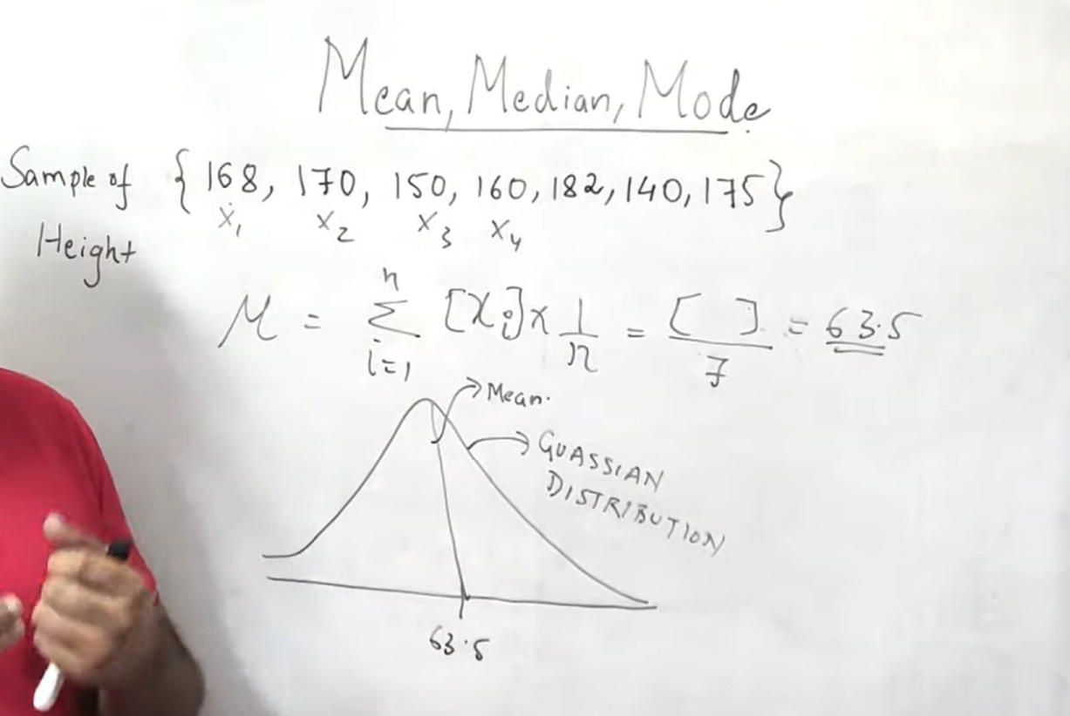

Mean is measure of central tendency.

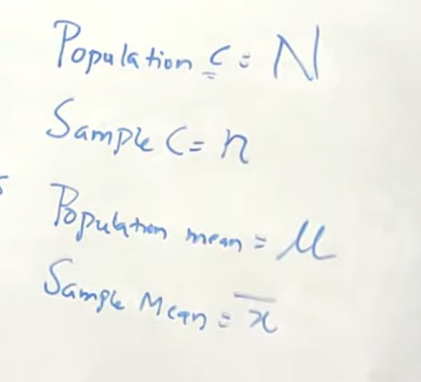

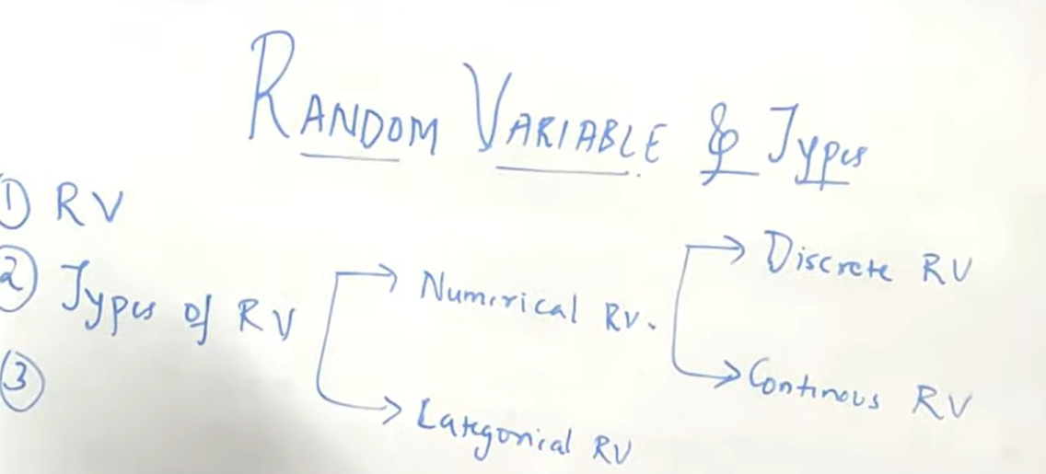

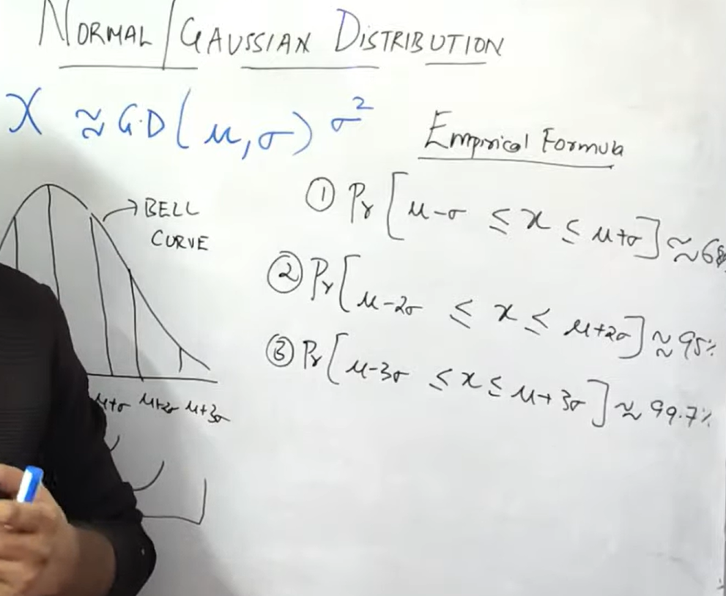

**CENTRAL LIMIT THEOREM**

X belong to some Gaussian distribution with(µ, σ^2)

There are 100 Samples, with their mean. And if all mean is taken and if we plot them on histogram, so X bar belong to the Gaussian distribution with (µ, σ^2)

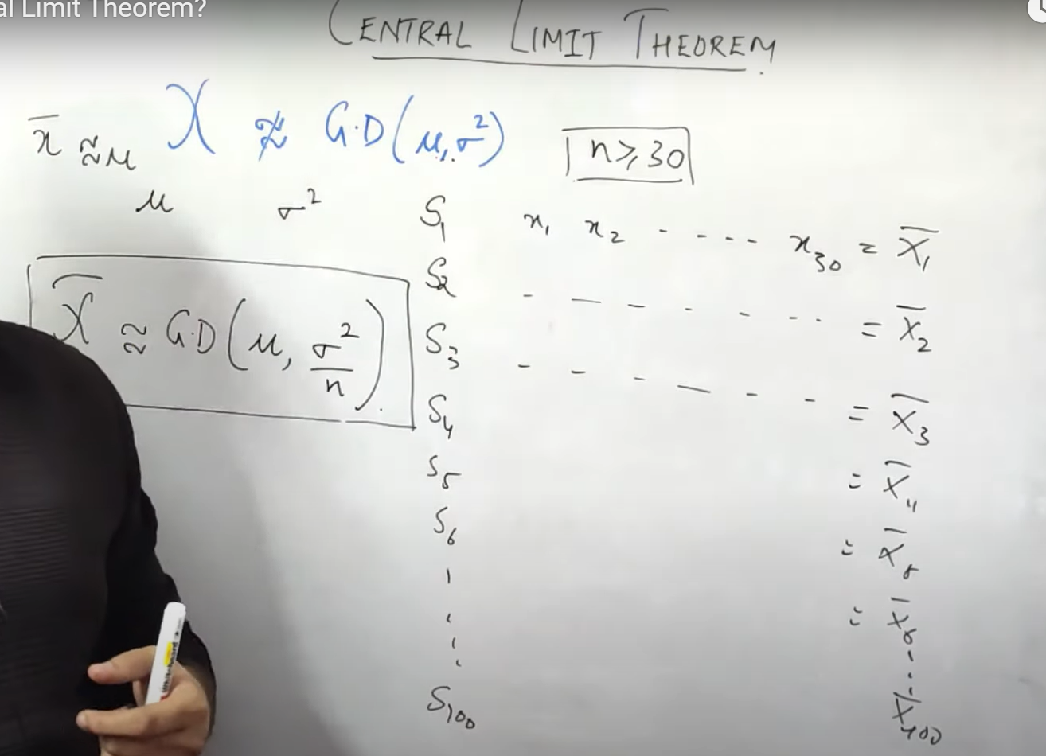

**Chebyshev’s Inequality**

Chebyshev’s inequality is similar to the 68-95-99.7 rule; however, the latter rule only applies to [normal distributions](https://corporatefinanceinstitute.com/resources/data-science/normal-distribution/). Chebyshev’s inequality is broader; it can be applied to any distribution so long as the distribution includes a defined variance and mean.

Chebyshev’s inequality states that within two standard deviations away from the mean contains 75% of the values, and within three standard deviations away from the mean contains 88.9% of the values. It holds for a wide range of probability distributions, not only the normal distribution.

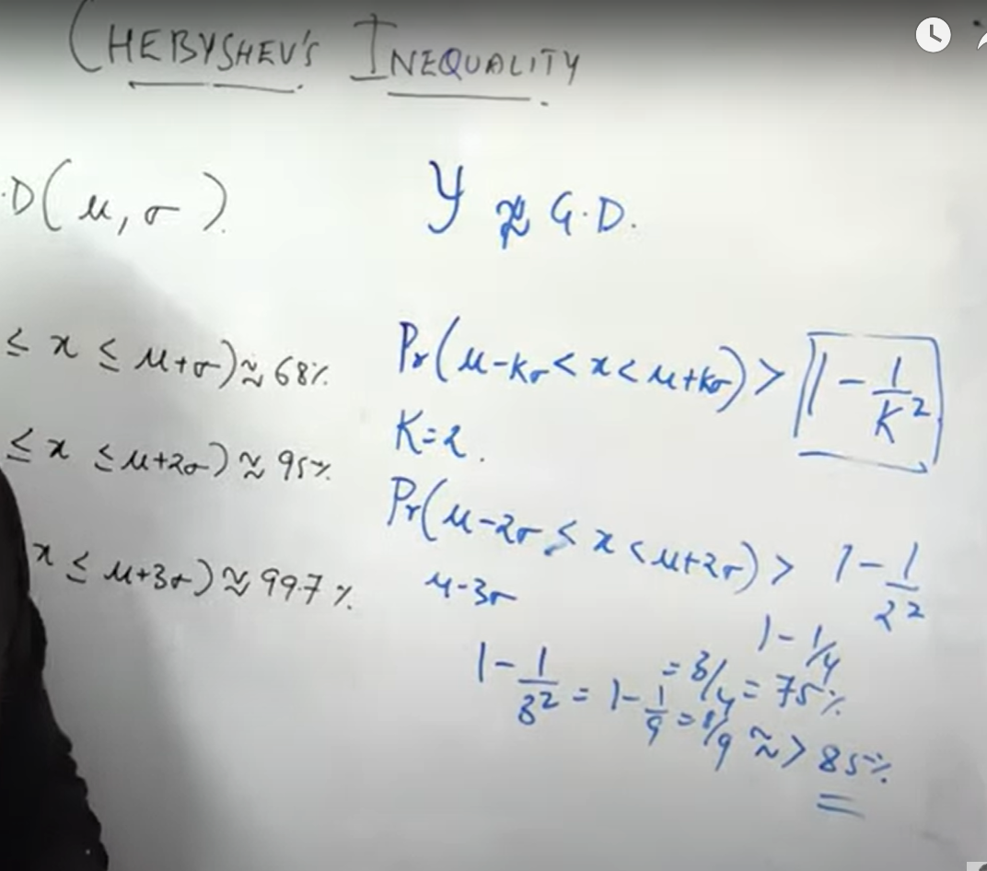

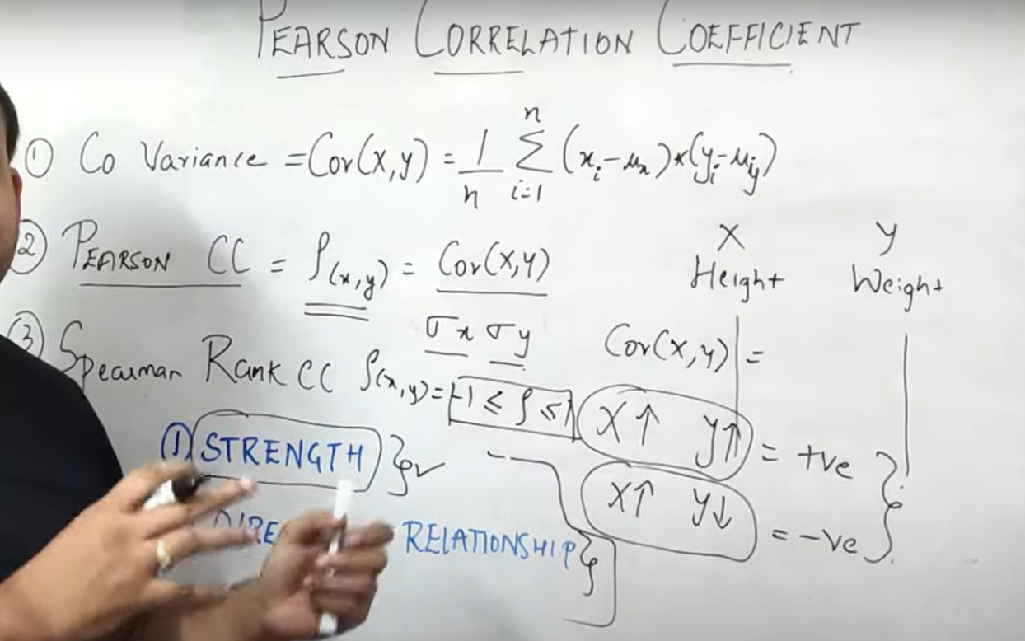

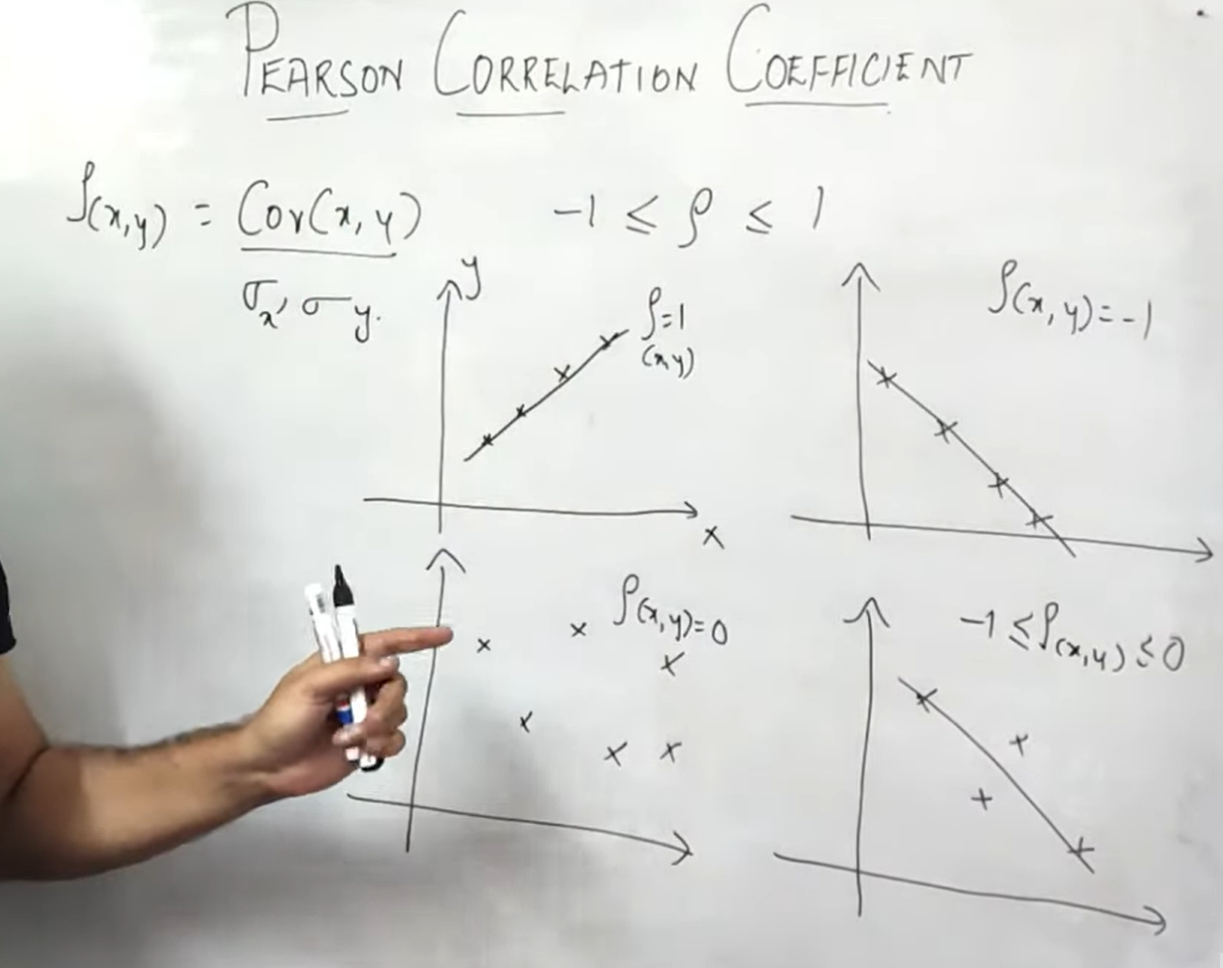

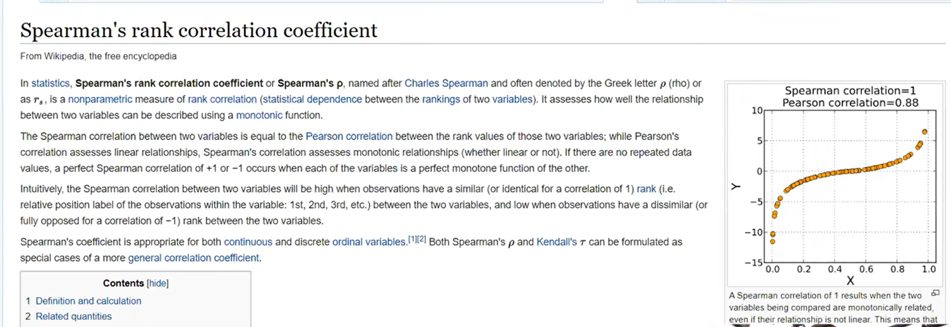

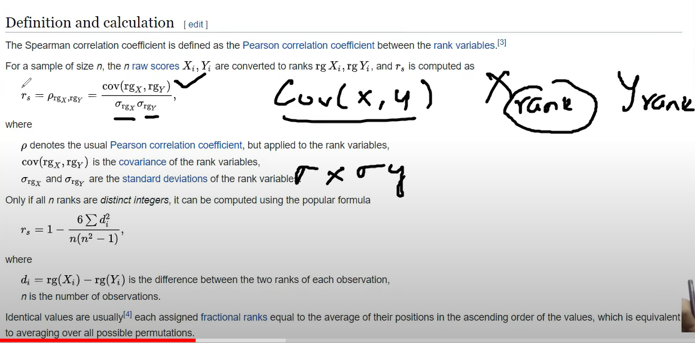

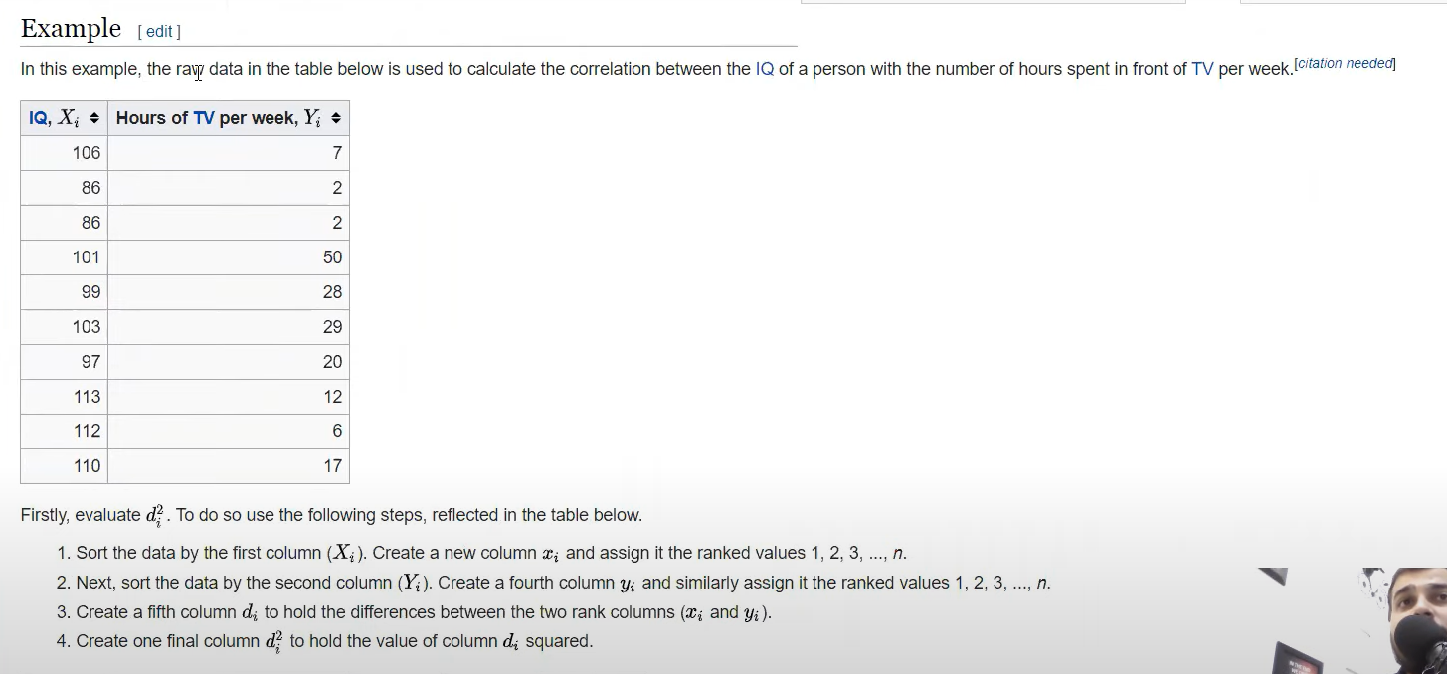

|  |  |  |  |  |  |
| --- | --- | --- | --- | --- | --- |
| Xi | Yi | rank xi | rank yi | di | di^2 |
| 86 | 0 | 1 | 1 | 0 | 0 |
| 97 | 26 | 2 | 6 | -4 | 16 |
| 99 | 28 | 3 | 8 | -5 | 25 |
| 100 | 27 | 4 | 7 | -3 | 9 |
| 101 | 50 | 5 | 10 | -5 | 25 |
| 103 | 29 | 6 | 9 | -3 | 9 |
| 106 | 7 | 7 | 3 | 4 | 16 |
| 110 | 17 | 8 | 5 | 3 | 9 |
| 112 | 6 | 9 | 2 | 7 | 49 |
| 113 | 12 | 10 | 4 | 6 | 36 |

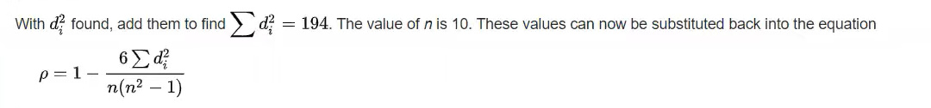

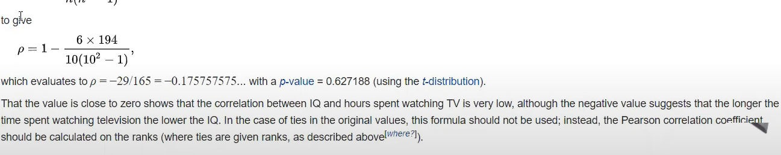

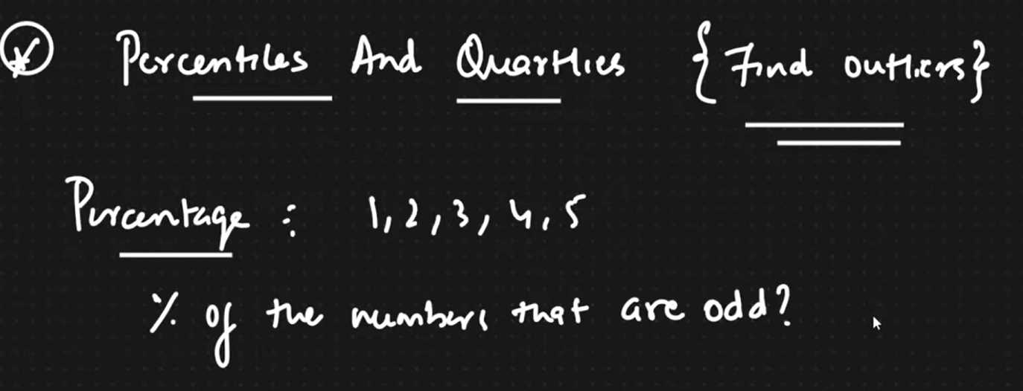

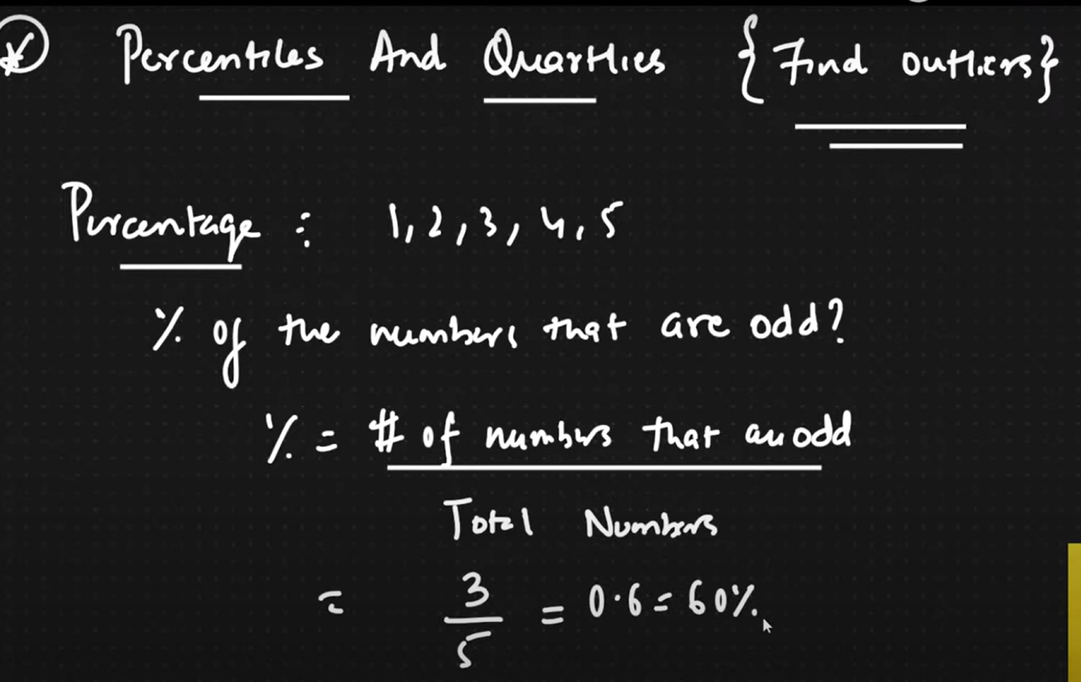

A percentile is a value which a certain percentage of observation lie.

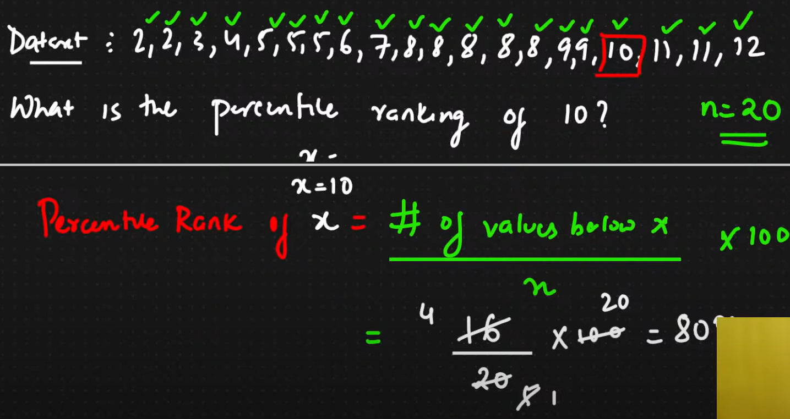

Percentile ranking of x=11, x=17/20*100=85%

Si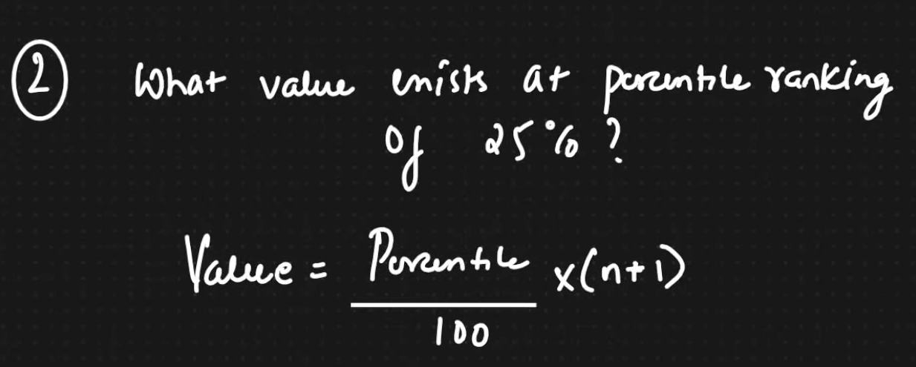

Value = 25/100*(20+1)=21/4=5.25-> Index position, here 5th and 6th index taken avg. and we get 5.

Similarly 75%percentile= 75/100*(20+1)=3/4*21=63/4=15.75.

Values between 15th and 16th position are 9 and 9. So the avg is 9.

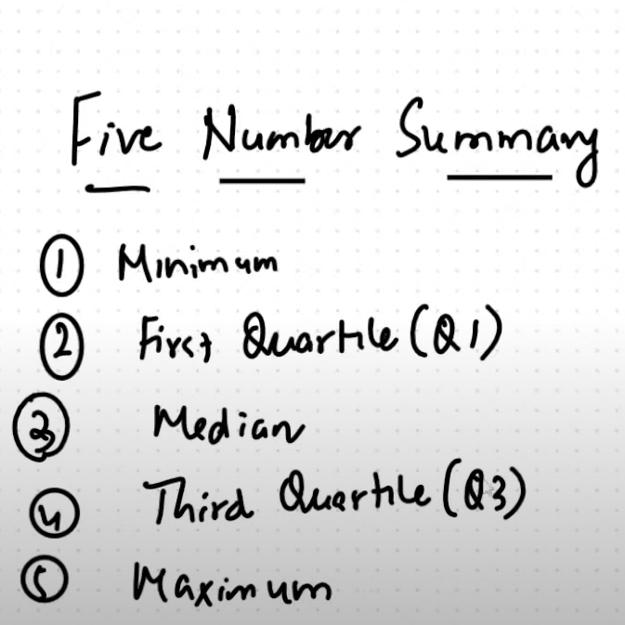

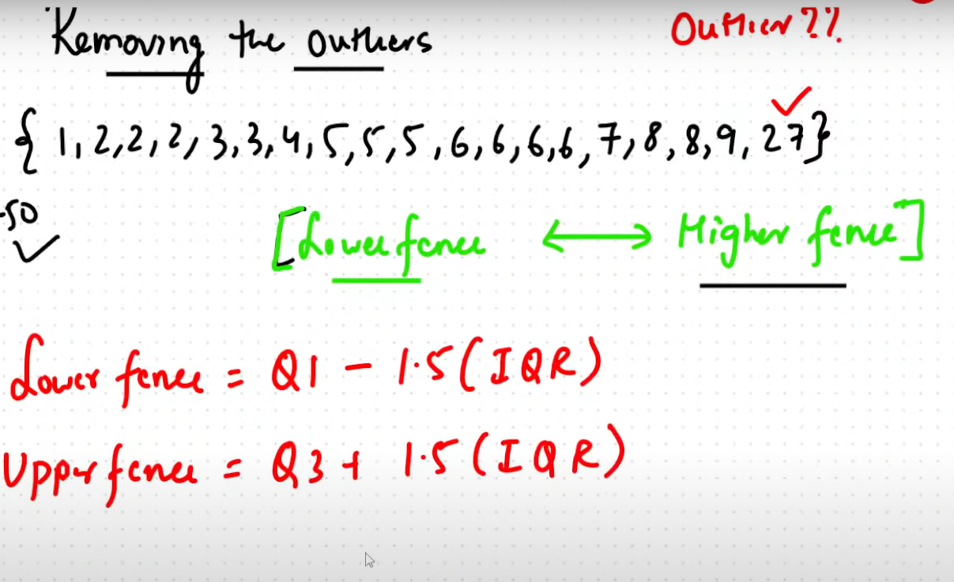

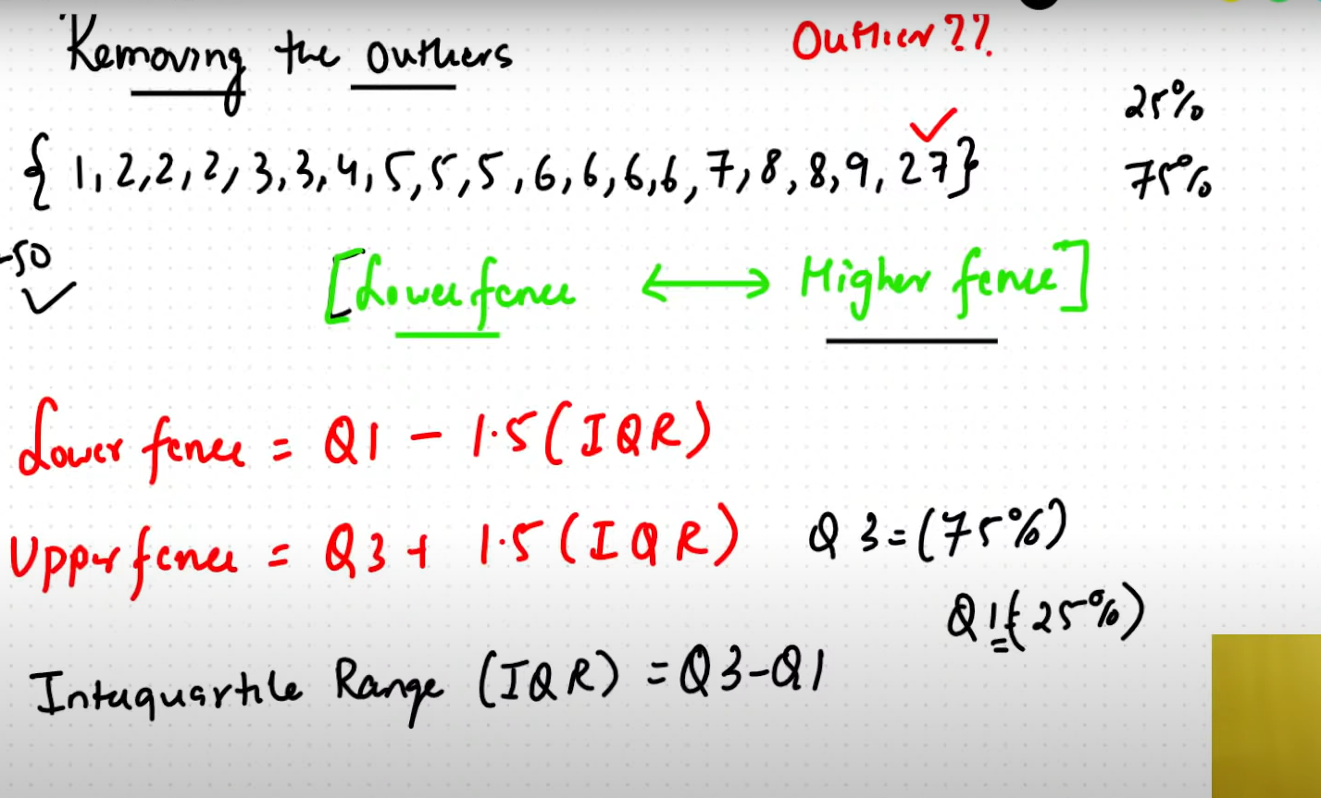

25%percentile= 25/100*(19+1)=20/4=5th index=3

75% percentile= 75/100*(19+1)=3/4*20=15th index= 7

IQR=Q3-Q1= 7-3= 4

Lower Fence= Q1- 1.5(IQR)= 3-1.5*4=3-6=-3

Higher fence= Q3 + 1.5(IQR)= 7 + 1.5*4=7+6 = 13

